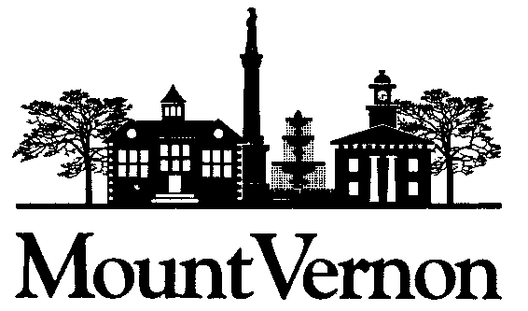
An Innovative Community; Authentically Hometown

MEDIA ALERT: Water Leak Detection on East Chestnut
Work Continues with Street Closure Maintained

MOUNT VERNON – Workers with the City of Mount Vernon as well as outside contractors continued their efforts Thursday to find the source of a water leak on East Chestnut Street between North Main and North Gay streets. East Chestnut Street remains closed in the vicinity of Mount Vernon City Hall and Municipal Court, and traffic is being rerouted from East Chestnut to East High Street and the Public Square. As of Thursday morning, no estimate of when the street will be reopened was available.

The City Water Department believes the leak can be traced to a lightning strike that caused a water main break on East Chestnut Street between North Main and North Gay streets on Aug. 12. After that water main break was fixed, however, the leak persisted. Workers are looking for the source of the leak uphill from the location.

On Thursday morning, an unrelated water main break occurred on Fearn Avenue at Mansfield Road, requiring several workers at the East Chestnut site to turn their attention to fixing that break.

Updates will be issued as soon as the water leak on East Chestnut Street is resolved and the street is reopened.

### END ###

ABOUT THE CITY OF MOUNT VERNON:
The City of Mount Vernon is an innovative community with an authentic hometown feel. Home to 17,000 people, Mount Vernon is the county seat for Knox County and boasts historic buildings and districts as well as business and professional, educational, and recreational opportunities through many adaptive reuses of the community’s infrastructure and spaces. Specific attractions are the historic Woodward Opera House, the Knox County Memorial Building and Theater, and the 250-acre Ariel~Foundation Park adjacent to the state scenic Kokosing River. The City has strong ties to higher education, with Mount Vernon Nazarene University, Kenyon College, and Central Ohio Technical College operating satellite locations in the historic downtown. Located 40 miles northeast of Columbus, Mount Vernon is near the geographic center of Ohio and has connections all over the globe.

CONTACT: Todd Hill
PHONE: (740) 393-9517
DATE: September 9, 2021

